Solution Design Document

SUPERIOR COURT OF CALIFORNIA

**Process Name**:

**Prepared by**:

**Date Prepared**:

**Last Updated**:

**Version**: 1.0

TABLE OF CONTENTS

1 DOCUMENT HISTORY 3

2 DEVELOPERS 3

3 GLOSSARY OF TERMS 3

4 Field Mapping 3

5 DATABASE 4

6 SQL QUERIES 6

7 DETAILED PROCESS FLOW 8

8 FLOW CHART 10

9 EXCEPTIONS 11

10 PROCESS CONFIGURATION 11

# DOCUMENT HISTORY

|  |  |  |  |
| --- | --- | --- | --- |
| **Version** | **Description** | **Date** | **Author** |
| 1.0 | Initial Draft | 12-05-2020 |  |

# DEVELOPERS

|  |  |
| --- | --- |
| **Name** | **Package Version** |
| Bharti |  |

# GLOSSARY OF TERMS

The following table includes definitions for any abbreviations or notations that are used in the document:

|  |  |
| --- | --- |
| **Term** | **Definition** |
| RPA | Robotic Process Automation |

# 4 Field Mapping

The below Table shows the mapping between RPA Database field , QAD Field and SharePoint field

|  |  |
| --- | --- |
| **Odyssey** | **Odyssey E-file CA** |
|  | EReq_SupplierCode |
| ShipTo | EReq_PlantName |
| OrderDate | EReq_EreqCreated |
| DueDate | EReq_DueDate |
| Buyer | EReq_BuyerCode |
| Site | EReq_Site |
| Project | EReq_ProjectCode |
| CreditTerms | EReq_CreditTerms |
| Req | EReq_Req |
| ItemNumber | EReq_PartNumber |
| Qty Ordered | EReq_Quantity |
| UM | EReq_UnitOfMeasure |
| Purchase Cos | EReq_UnitPrice |
| Description | EReq_PREQDescription |
| Pur Acc | EReq_Account |
| Cost | EReq_CostCenter |
| FOB | EReq_FOB |
| Shipvia | EReq_ShipVia |

# 7 DETAILED PROCESS FLOW

Step 1 – Robot will login both Odyssey and Odyssey E-file CA with valid credentials.

Step 2 – Robot Choose Stanislaus-Family in the All Queues drop down and Click filter.All the cases waiting in the Family Law queue will appear in this window.

New cases are designated with an Envelope #

Step 3 – Opening New Cases via E-file

1. Click the “play” button to start the review of the document

3 different windows will appear-

Step 4 – Robot will visit the menu option 5.7 and insert the records.

Step 5 – Robot will update the following QAD Fields,

|  |  |  |
| --- | --- | --- |
| **Screen 1** | **Screen 2** | **Screen 3** |
| * Purchase Order * Supplier * Ship To * Order Date * Due Date * Buyer * Site * Project | * Ln * Req * Item Number * Qty Ordered * UM * Purchase Cos * Description * Account * CostCenter | * FOB * ShipVia |

Step 6 – Robot will start with Screen1 and following takes place,

* If there is an error, it will skip that record and proceed with the next record
* If there is no error,it will proceed with the next screen.

Step 7 – Once Screen 1 is successfully executed, Robot will proceed with Screen 2. Part Details are inserted and If there is an error, it will skip that part detail and proceed with the next part detail and continue until all the part details are processed.

Step 8 – Once the Screen 2 is completed,Status of all the parts is compared and only if all the parts has “Success” Status, Robot will proceed with Screen 3, else will discard that record and proceed with the next record

Step 9 – Robot will enter the details in Screen 3 and following takes place,

* If there is an error, it will skip that record and proceed with the next record
* If there is no error,PO Number will be generated successfully and Update the “ApprovedEreqPO” Sharepoint list using “Update List Items

Step 10 – Same steps are repeated for all the records.

Step 11 – After completion of the process, Robot will disconnect from the QAD system,RPA Database and Sharepoint application and notify the user via mail with log file

# 8 FLOW CHART

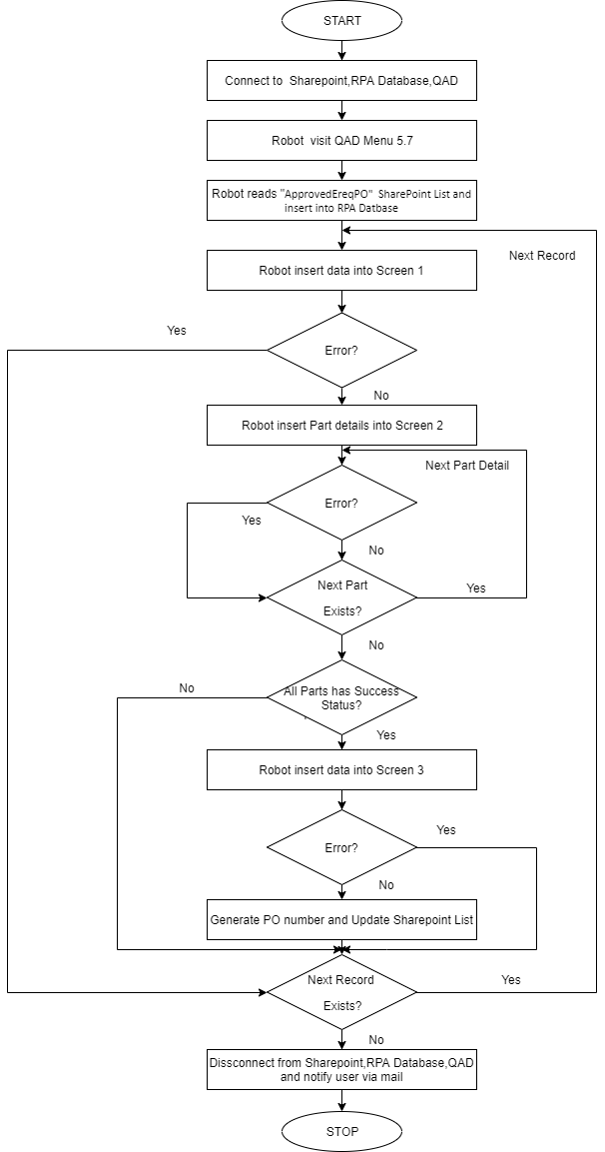

# 9 EXCEPTIONS

1. **Application Exception**

|  |  |  |
| --- | --- | --- |
| **SL NO** | **EXCEPTION** |  |
| 1 | Database connectivity issues | Connection has to be stable |
| 2 | QAD connectivity issues | Connection has to be stable |
| 3 | SharePoint connectivity issues | Connection has to be stable |

1. **Business Exception**

|  |  |  |
| --- | --- | --- |
| **SL NO** | **FIELD** | **EXCEPTION** |
| 1 | Supplier | Not a valid Supplier |
| 2 | Ship To | Ship To does not exist |
| 3 | Order Date/Due Date(invalid month) | Month of a date should be from 1 to 12 |
| 4 | Order Date/Due Date(Invalid day) | Day in a month is invalid |
| 5 | Order Date/Due Date(Invalid year) | Invalid period/year |
| 6 | Buyer | Value must exist in generalized codes |
| 7 | Site | Invalid Site |
| 8 | Project | Invalid Project |
| 9 | Currency | Invalid Currency Code |
| 10 | UM | Value must exist in generalized codes |
| 11 | Pur Account | Invalid account code |
| 12 | FOB | Value must exist in generalized codes |
| 13 | ShipVia | Value must exist in generalized codes |

# 10 PROCESS CONFIGURATION

1 - “Config.xlsx” Contains all the Config data like Menu Option, Sharepoint List Name etc. used in the Process.